Statement Regarding Racial Injustice and Inequality

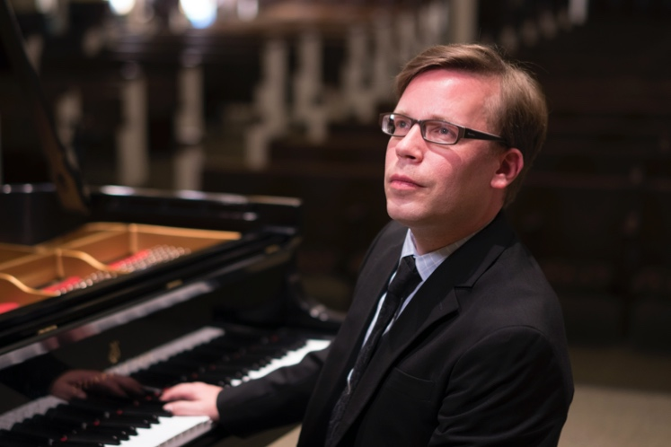
Music has the power to bring forth healing. Therefore, we consider it our noblest task to make this power available to everyone. WVMTA explicitly and intentionally welcomes students and teachers of all minorities – for us, a child is just a child, and music is a language spoken by all.

I know from the bottom of my heart that every member in our organization fervently strives to make this world a more equitable place - in every piano lesson, at every violin Christmas recital, during every band rehearsal, and on every choir tour.

In the context of the tragic and unnecessary death of George Floyd in May 2020 and the ensuing nationwide movement to fight racial injustice, we affirm our intrinsic desire to work toward a future in which the color of one’s skin is really just that. We won’t reach this goal by tomorrow - a long and rocky road lies ahead of us. We also can’t erase history. Thus, on the way, we will have to make a conscious effort to keep everyone strong and healthy.

As a small token of our sincerity, WVMTA will support one African American student with an annual scholarship, starting in the academic year 2020/2021. For more information, please refer to the June 2020 Newsletter at https://www.wvmta.org/newsletter .

Sincerely,

Dr. Henning Vauth
President

